Issue : January 2018
N°. 2047
Scotch® Masking Tape 2071
Description
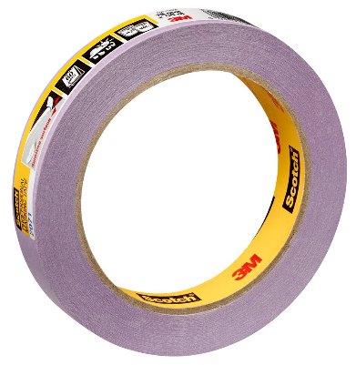
Scotch Masking Tape 2071 is a low adhesion tape, ideal for paint masking on most fresh paints (24 hours old), vinyl-coated wallpapers, primed wallboard, wood floor and faux painting. It can be removed cleanly from the surface for up to 60 days even in direct sunlight.
Product characteristics
Backing | Washi flat paper
Adhesive | Acrylic Adhesive
Standard roll length | 50 m
Color | Purple

Typical Physical properties | value | Method
Total thickness | 102 µm | ASTM D-3652
Adhesion to steel | 1,7 N/cm | ASTM D-3330
Tensile strength | 35 N/cm | ASTM D-3759
Elongation at break | 7,5 % | ASTM D-3759
The above technical information and data should be considered representative or typical only and should not be used for specification purposes.

Precautions
Do not use with or on nitrocellulose lacquer coating
Do not use on paper, unprimed wallboard or rough surfaces.
In case of doubt make a trial in an inconspicuous area.

Features /Advantages / Benefits
Characteristics | Advantages | Benefices
Acrylic Adhesive | Adhesive transfer resistance | Sticks easily to surfaces and stays intact upon removal  Reduce labor and rework
 | Increase light and UV stability | Clean removal  Reduces labor
 | Low adhesion | Easy to use
Thin flat paper | Smoothness | Consistent surface contact, super sharp paint line
Backing saturant | Solvent and moisture resistance | Resist paint bleed through and adhesive does not soften or transfer when tape is wet
Backsize treatment | Controlled unwind | Smooth unwind

Important notice:
The use of the 3M product described within this document assumes that the user has read and understood the user notice. Before any use of this product it is recommended to complete some trials to validate the performance of the product within its expected purpose.
All information and specification details contained within this document are inherent to this specific 3M product and would not be applied to other products or environment. Any action or usage of this product made in violation of this document is at the risk of the user.
Compliance to the information and specification relative to the 3M product contained within this document does not exempt the user from compliance with additional guidelines (safety rules, procedures). Compliance to operational requirements especially in respect to the environment and usage of tools with this product must be observed. The 3M group (which cannot verify or control those elements) would not be held responsible for the consequences of any violation of these rules which remain external to its decision and control.
Warranty conditions for 3M products are determined with the sales contract documents and with the mandatory and applicable clause, excluding any other warranty or compensation

